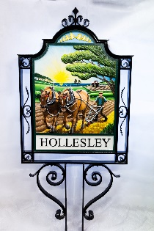
HOLLESLEY PARISH COUNCIL
Ms Clare Cooper, Clerk to the Council
34 Swallows Close, Hollesley, Woodbridge Suffolk IP12 3RW

Tel: 07354 428705 clerk@hollesley-pc.gov.uk

Resident’s Questionnaire

The Parish Council wish to find out resident’s views about a proposed 20mph speed limit in accordance with the map below:

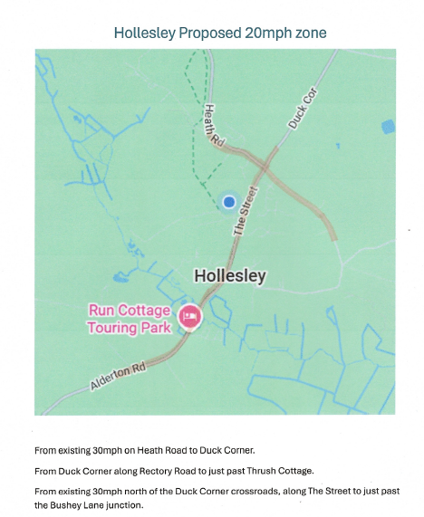

Do you support the idea given that this will cost the Parish Council in the region of
£10-12,000? YES/NO

Would you stick to a 20mph speed limit? YES/NO

Do you believe that most people would adhere to the new limit? YES/NO

Do you think this would improve road safety in Hollesley? YES/NO

What are your views on the routes selected?

Please add any further comments you may have below:

Many thanks for sharing your views.
Your completed form should be returned to the Clerk.

